

CS4092 Final Year Project

FAST Karachi Campus

**Car recovR**

**Submitted By**

Muhammad Eahtesham 19K-0298

Uzair Khan 19K-1477

Muhammad Hassaan Ahsan Qureshi 19K-0272

Project Progress Report

To the Department of Computer Science

National University of Computer and Emerging Sciences

Date of delivery: Friday 17th February 2023

**Table of Contents**

**1. INTRODUCTION** **3**

**2. TIMELINE** **4**

**3. PROGRESS** **4**

3.1 CAR REGISTRATION FRONTEND 4

3.2 CAR REGISTRATION BACKEND 4

3.3 CAR REGISTRATION INTEGRATION 4

3.4 COMPLAINT REGISTRATION FRONTEND 4

3.5 COMPLAINT REGISTRATION BACKEND 4

3.6 COMPLAINT REGISTRATION INTEGRATION 4

3.7 USER LOGIN SIGNUP FRONTEND 4

3.8 USER LOGIN SIGNUP BACKEND 4

3.9 USER LOGIN SIGNUP INTEGRATION 5

3.10 SURVEILLANCE SYSTEM FRONTEND 5

3.11 SURVEILLANCE SYSTEM BACKEND 5

3.12 SURVEILLANCE SYSTEM INTEGRATION 5

3.13 ALERT MODULE FRONTEND 5

3.14 ALERT MODULE BACKEND 5

3.15 ALERT MODULE INTEGRATION 5

3.16 MODEL TRAINING FRONTEND 5

3.17 MODEL TRAINING BACKEND 5

3.18 MODEL TRAINING INTEGRATION 5

**4. UPDATED TIMELINE** **5**

**5. REFERENCES** **6**

# INTRODUCTION

As stated and discussed in our initial *FYP Defense* of **FYP I**, we started the goal and objective of this project, **Car recovR**, to be,

“A technological solution to recover a stolen Car in the city.”

The primary goal of Car recovR is to provide a platform to help recover stolen vehicles quickly and efficiently. This is typically achieved through a combination of technology and collaboration with law enforcement agencies and other relevant authorities.

This software project aims to provide registration, complaint registration and surveillance of traffic which can help to provide such ecosystem in which all cars are registered in a system to provide security to all the cars and if someone steals a car from such a system so the car can be recoverable in just a matter of time after launching the complaint and right after they locate in surveillance system. Car recovR attempts to provide multiple features together to reduce complexity levels, high intense communication needs, and remove redundancy in information sharing, alerts, events, updates, and so on.

On the high level, the project attempts to (for now) bring together 3 main components together as integration pieces, which are,

1. Car Registration System
2. Complaint Registration System
3. Surveillance System

These are the main high level components of the system that define the functional requirements for the project. All together, these components encapsulate entities logic for the detection system, registration process, complaint process and surveillance process (and more).

# TIMELINE

Following is the timeline before proposal defense in *FYP-I* for this project.

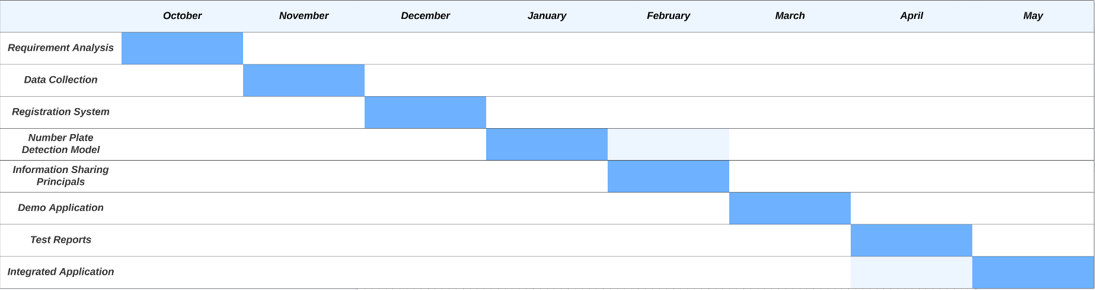

# PROGRESS

This section elaborates on the milestones/tasks mentioned in the updated timeline of our project in more detail, the work they entail, and the progress regarding them.

## 3.1 CAR REGISTRATION FRONTEND

The frontend of car registration is completed.

## 3.2 CAR REGISTRATION BACKEND

The backend of car registration is completed.

## 3.3 CAR REGISTRATION INTEGRATION

The car registration is integrated in the system with a detection module.

## 3.4 COMPLAINT REGISTRATION FRONTEND

The frontend of complaint registration is completed.

## 3.5 COMPLAINT REGISTRATION BACKEND

The backend of complaint registration is completed.

## 3.6 COMPLAINT REGISTRATION INTEGRATION

The complaint registration is integrated in the system.

## 3.7 USER LOGIN SIGNUP FRONTEND

\ The frontend of user login and signup is completed.

## 3.8 USER LOGIN SIGNUP BACKEND

The team is currently working on the backend.

## 3.9 USER LOGIN SIGNUP INTEGRATION

Integration will be done once the backend is completed

## 3.10 SURVEILLANCE SYSTEM FRONTEND

We are working on the backend aspect of the surveillance system. Therefore, we will work on it once the backend part is completed

## 3.11 SURVEILLANCE SYSTEM BACKEND

As discussed before, we are currently working on the backend of the surveillance system.

## 3.12 SURVEILLANCE SYSTEM INTEGRATION

The integration will be finished after the completion of frontend and backend.

## 3.13 ALERT MODULE FRONTEND

The team will start working on frontend of alert module once the above modules are completed.

## 3.14 ALERT MODULE BACKEND

The team will start working on backend of alert module once the above modules are completed.

## 3.15 ALERT MODULE INTEGRATION

Integration of alert module will be finished once the above modules are completed

## 3.16 MODEL TRAINING FRONTEND

The frontend of the model training module is blocked due to the working of the backend of model training.

## 3.17 MODEL TRAINING BACKEND

A submodule of backend i.e object detection of number plates is completed. Whereas, the other submodule i.e real time detection of cars is in progress.

## 3.18 MODEL TRAINING INTEGRATION

The integration will be finished after the completion of backend and frontend of model training

# UPDATED TIMELINE

This section depicts the updated timeline of *FYP-I* & *FYP-II* respectively for the year 2022-23. The gantt chart is on the next page which shows the completion and expected completion of remaining modules of th project.

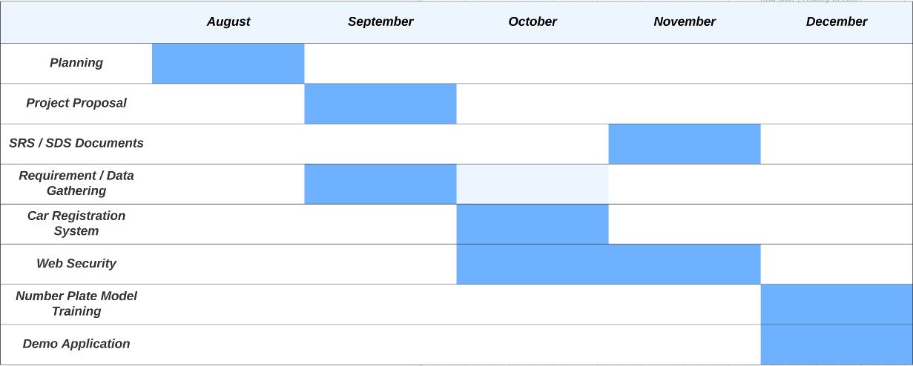

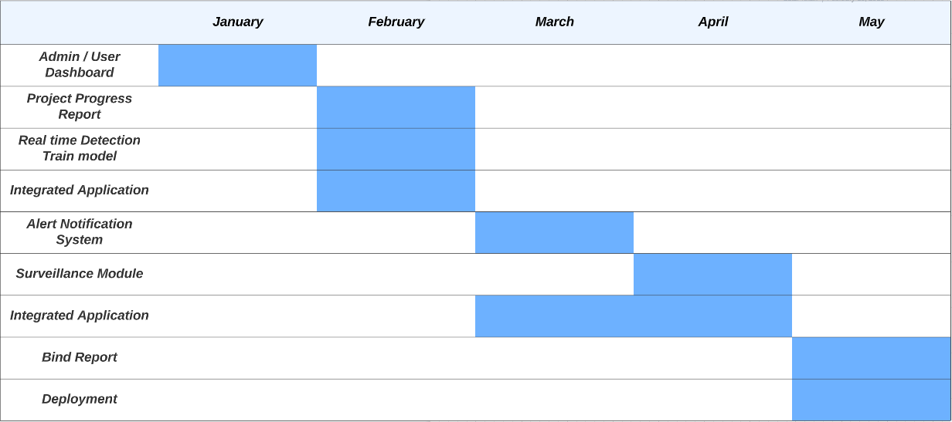

# REFERENCES

Not Available